**Classification**

Each of us select a classification method and then select two variables, one to be classified by ourselves and one to be compared with the other methods, as clustering. Possible variables are *emotion*, *emotion_positivity*, *emotional_intensity* and *sex*. We select these variables because they seem to us the most interesting variables to predict.

The dataset used for this part is the same used in the data preparation and understanding part, also used for clustering. After applying the algorithm for all these attributes, the one that came out to be the most interesting is the *emotion*.

**“emotion”**

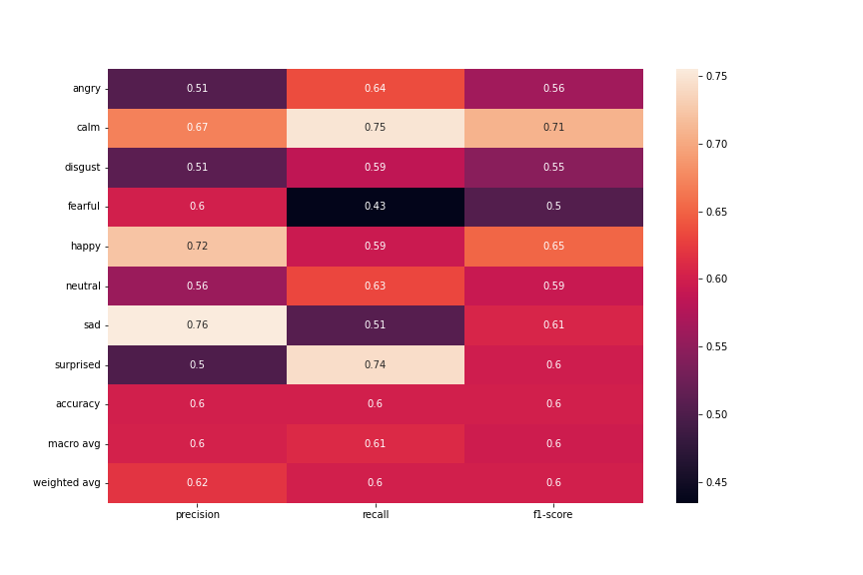

Figure 1: classification report of "emotion" attribute

Poor model reliability for the *emotion* prediction, because the accuracy is of 60%. The highest precision is of *sad* class with 0.76, which has the best TP/FP ratio and the lowest FP support. The highest recall is of *calm* class with 0.75, which has the best TP/FN ratio but not the lowest FN support. Also the *calm* class has precision of 0.67 and is the most "balanced" class, for this reason the highest f1-score is of *calm* class, since the latter is both sensitive to FP and FN.

Figure 2: confusion matrix of "emotion" attribute

In confusion matrix we have another proof of the *calm* class which has the highest TP support. We can also see that the *fearful* class has the highest FN support, in fact it has also the lowest recall (0.43), since the latter is sensitive to FN.

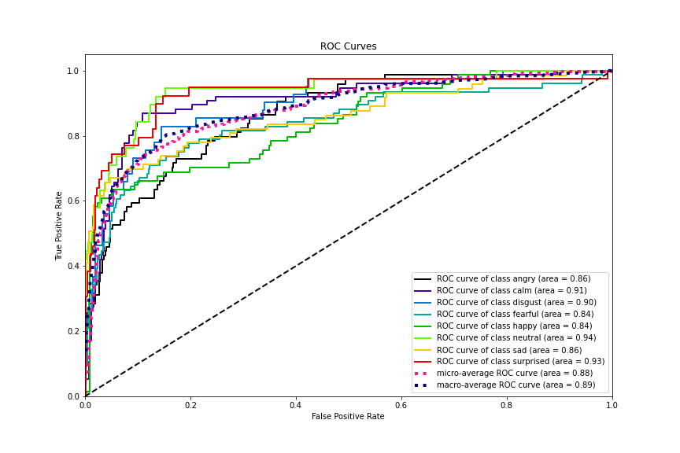

Figure 3: ROC curve of "emotion" attribute

In ROC curve plot we see what we can expect from everything we have said so far: the *calm* class has a high area value, lower only than *surprised* and *neutral* classes but they have a much lower support than *calm* one.

**“sex”**

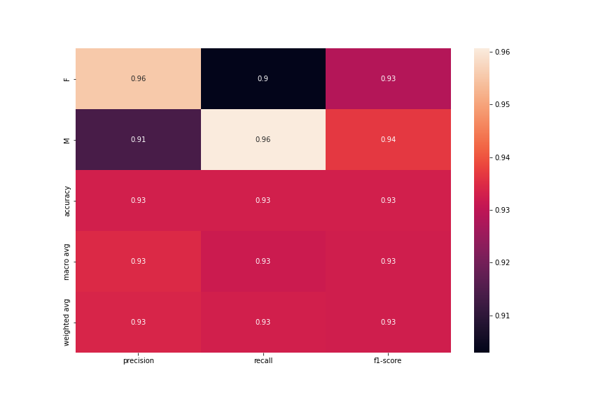

Figure 4: classification report of "sex" attribute

This case is not really interesting. The *sex* accuracy (93%) is higher than the *emotion* one, it is also the highest accuracy among all the chosen attributes, but we have also to take into account that *sex* is binary class problem. The *female* class has an higher precision (0.96) than *male*, in fact it has only 10 FP out of 491, but the highest recall is of *male* class (0.96), that means *female* has an higher FN value, 23 out of 491. However these numbers are really small compared to the total support and the differences are not so significant, in fact the f1-scores are similar, respectively 0.93 for *female* and 0.94 for *male*.

Figure 5: confusion matrix of "sex" attribute

Figure 6: ROC curve of "sex" attribute

**“emotional_intensity”**

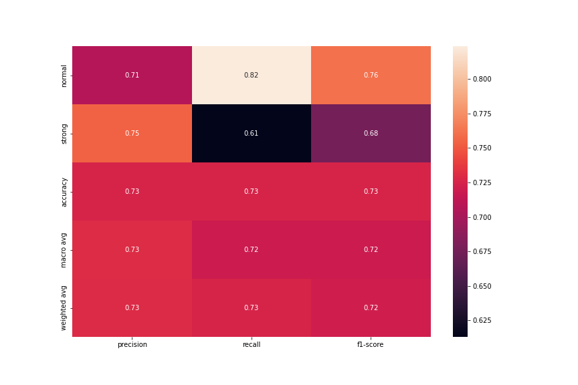

Figure 7: classification report of "emotional_intensity" attribute

This case is more interesting than *sex* attribute, despite also *emotional_intensity* is a binary class problem but accuracy is lower than the *sex* one (73% vs 93%). Precisions are similar among classes, with *strong* class which has a slightly higher value (0.75 vs 0.71). The recall is much higher in *normal* class (0.82 vs 0.61), which has also an higher f1-score (0.76 vs 0.68).

Figure 8: confusion matrix of "emotional_intensity" attribute

In confusion matrix we can see an higher FP value (89), which is quite close to the TN value (141).

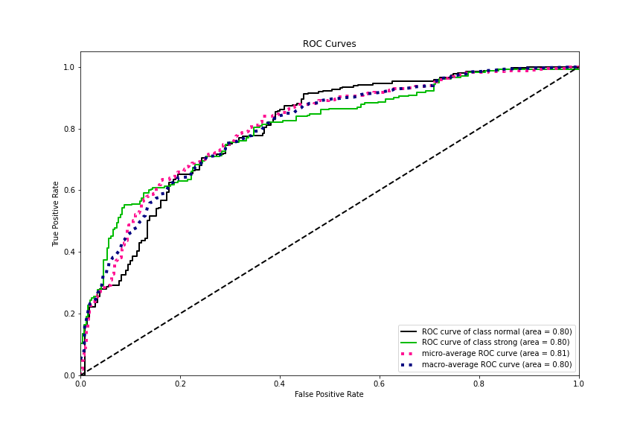

Figure 9: ROC curve of "emotional_intensity" attribute

**“emotion_positivity”**

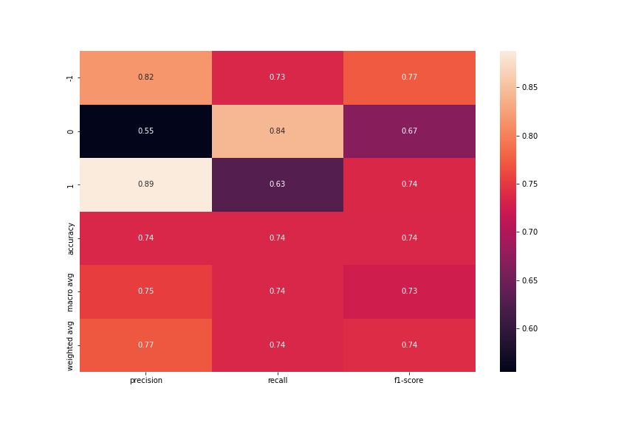

Figure 10: classification report of "emotion_positivity" attribute

The last one is *emotion_positivity* attribute, which is a three-class problem with the accuracy slightly higher than the *emotional_intensity* one (74% vs 73%). The *positive* emotions, the *1* class, have the highest precision (0.89), in fact they have only 9 out of 113 FP. On the other side *positive* emotions have the lowest recall, consequently the highest FN value (42), while the highest recall is of *neutral* emotions, the *0* class, which is 0.84. The f1-score but with much higher support. The highest recall is of *neutral* emotions, which is of 0.84, with the lowest number of FN (18).

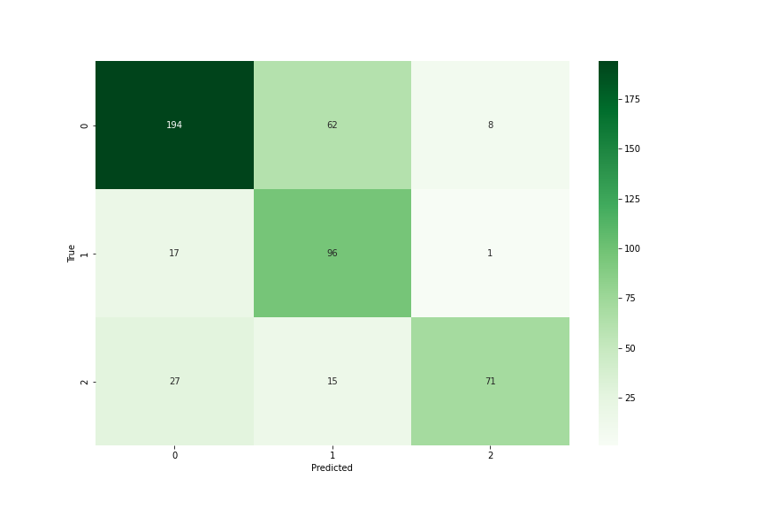

Figure 11: confusion matrix of "emotion_positivity" attribute

In confusion matrix we can see there is a spike of predicted *neutral* emotions which they actually are *negative* emotions, 62, which is quite close to *positive* emotions TP value (71).

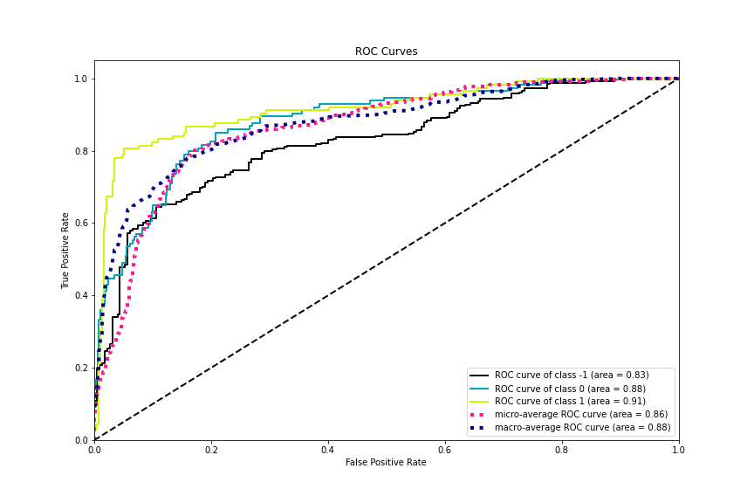

Figure 12: ROC curve of "emotion_positivity" attribute